NLP-Based Customer Support Ticket Classification System
Milestone 3: Model Evaluation
Team members: Patricia Atkinson, Katie Price, Alejandro Tovar Castillo, Galen Wu

1. Performance Metrics
For our classification system project we chose Accuracy, F1-score, Precision and Recall as the metrics to use for model evaluation. We also reviewed the Confusion Matrix to get better insight into the results.
Two model variants were trained for evaluation: Naïve Bayes with TF-IDF vectorization and Naïve Bayes with Bag of Words vectorization.
- Training Evaluation: The model training evaluation metrics for both are shown below.

Naïve Bayes with TF-IDF Vectorization
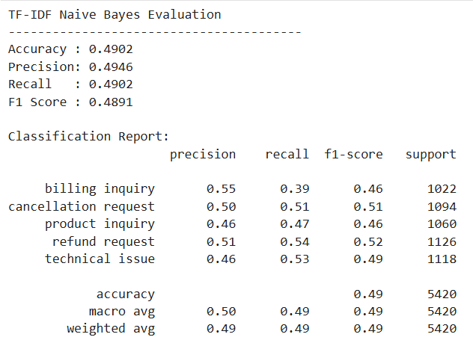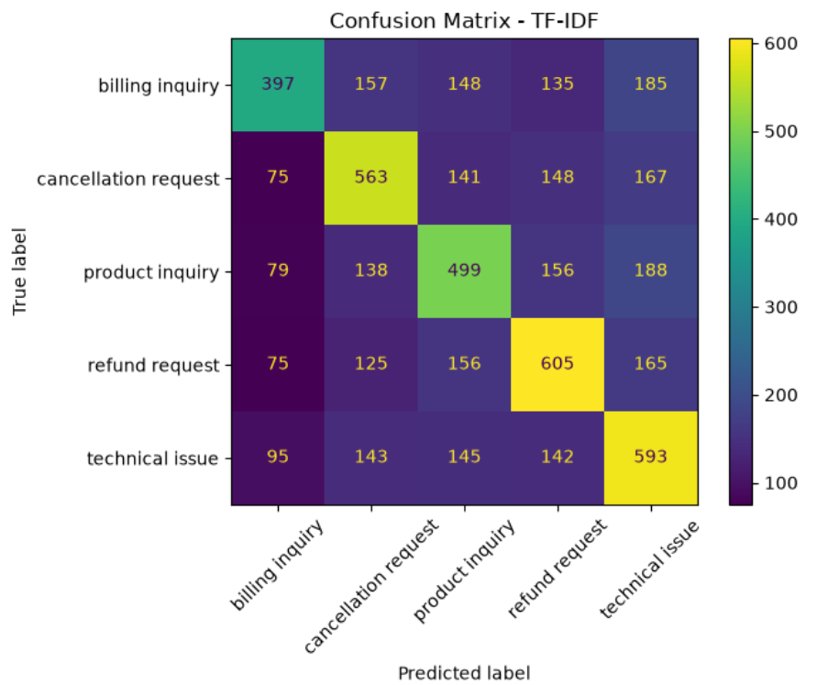
Naïve Bayes with Bag of Words Vectorization
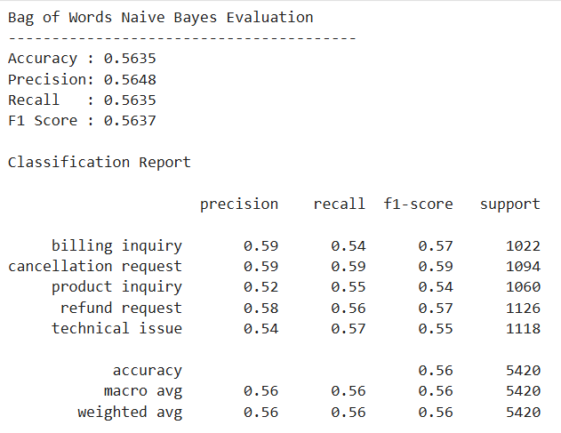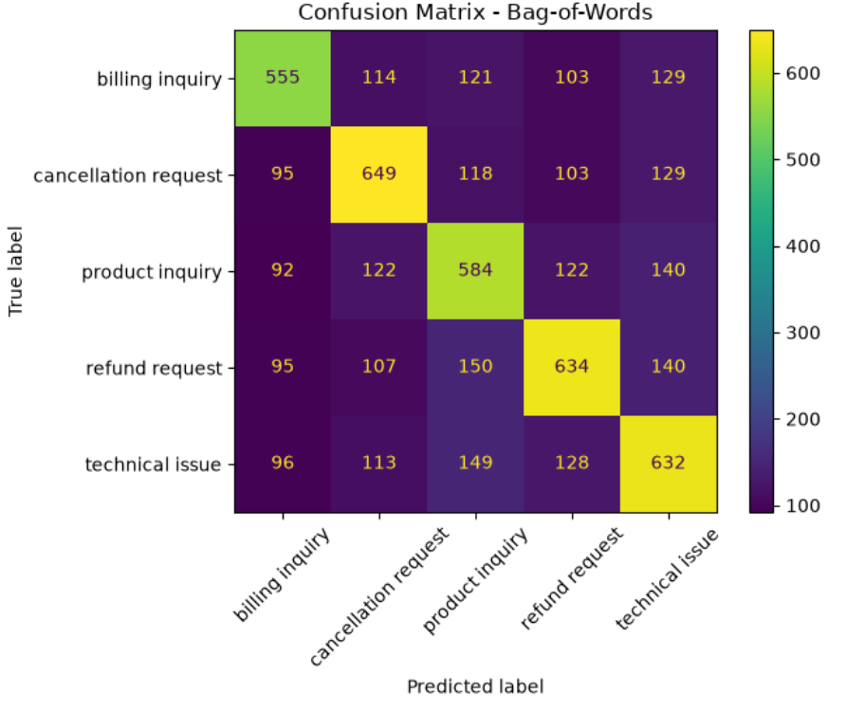
- Test Evaluation: The model test evaluation metrics for both are shown below.
Naïve Bayes with TF-IDF Vectorization
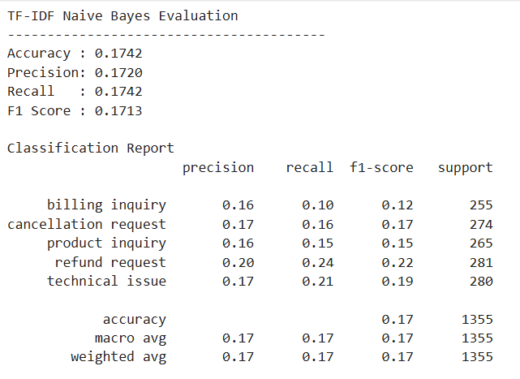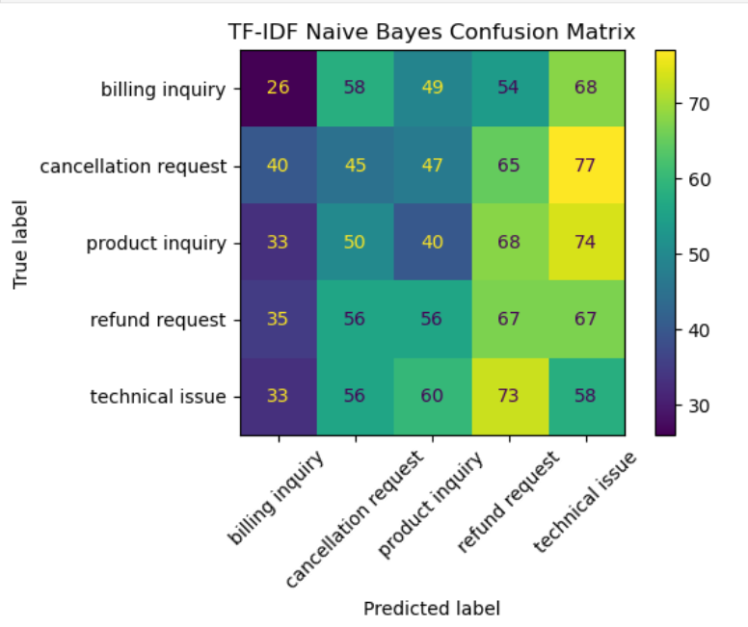
Naïve Bayes with Bag of Words Vectorization
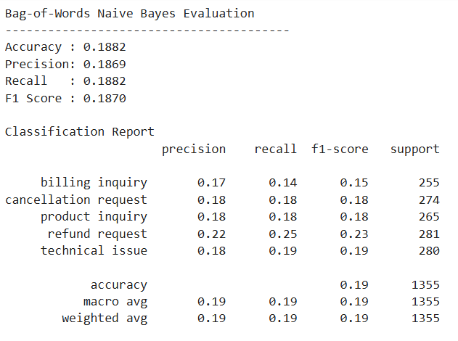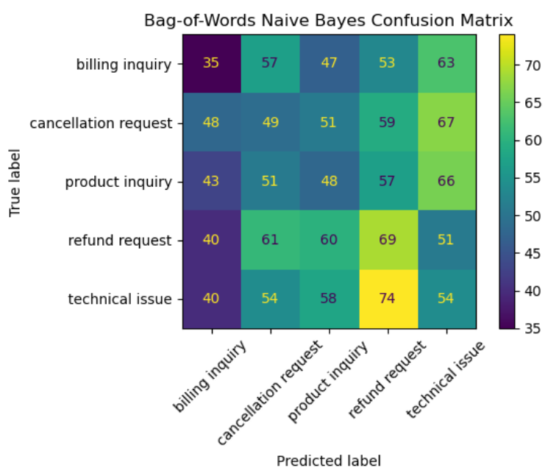
2. Analysis and Insights:
- Interpretation of the Results:
TRAINING RESULTS:
TEST RESULTS:
Both models perform poorly with the test data, having an accuracy of 0.17 and 0.19 respectively.

A low score for all four metrics (accuracy, precision, recall, and F1 Score) indicates that the model is performing poorly across the board. Because the metrics are all similarly low, the model is not effectively distinguishing between the different ticket categories. The accuracy of 0.17 – 0.19 is close to the random baseline of 0.20 for a five-class problem. This suggests that the model is learning little more than chance-level predictions.

The consistently low precision, recall, and F1 scores across classes indicate that the model struggles both to correctly identify each category and to make reliable predictions for those categories.

- Identify Strengths: Highlight areas where the model performs well and why.
- Discuss Limitations: Point out weaknesses, such as bias in data, overfitting, or poor generalization to unseen examples.
- Suggest Improvements: Based on the results, suggest possible refinements like hyperparameter tuning, data augmentation, or using a different model architecture.
- Ablation Studies (Optional): If feasible, conduct ablation studies to test how removing certain components (e.g., specific features, layers, or preprocessing steps) affects performance.
3. Error Analysis:
- Identify Common Mistakes: Look at incorrect predictions and group them by error type. For example, does the model confuse similar classes? Does it struggle with specific linguistic patterns?
- Analyze Failure Cases: Pick a few representative examples and examine why the model made mistakes. This can help uncover patterns that aren’t obvious from metrics alone.
- Develop Strategies for Improvement: Based on error trends, propose ways to address them, such as improving data preprocessing, modifying loss functions, or refining the model’s architecture.

